RTL-SDR Air Traffic Control/Aircraft Tracking

The purpose of this tutorial is to provide information about how an SDR can be used, and how people can use it for malicious purposes. This will provide a basic understanding on radio frequency listening/recording so that security personnel can better defend against such attacks. Under no circumstance should this tutorial be used for anything malicious or illegal!

- This tutorial assumes you have completed the RTL-SDR Sharp Installation Guide and are familiar with basic navigation on the SDRsharp UI.

The airband traffic control frequency range is from 108 Mhz to 137Mhz. If you are close enough to an airport, you might pick up on some frequencies as shown below.

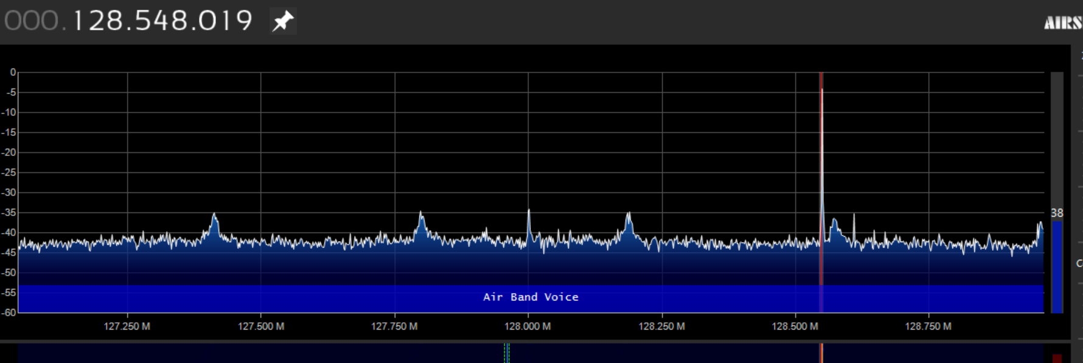

- Download and unzip dump1090 onto a new folder. Run the .bat file. You should see the command prompt below. This means your SDR is recognizing aircraft. If you get an error, refer to the notes section below.
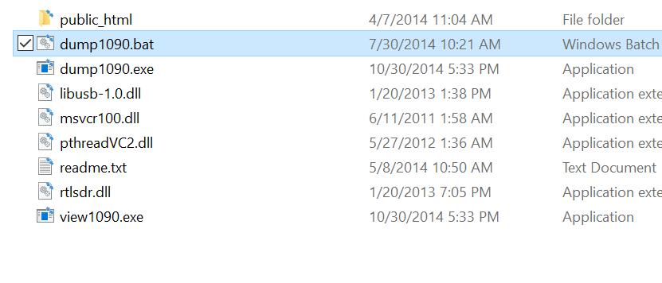
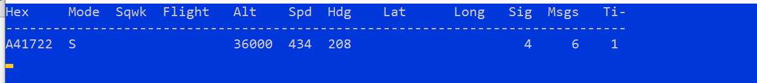

- Download Virtual Radio Server and follow the setup. This will allow us to see the aircraft graphically. http://www.virtualradarserver.co.uk/Download.aspx

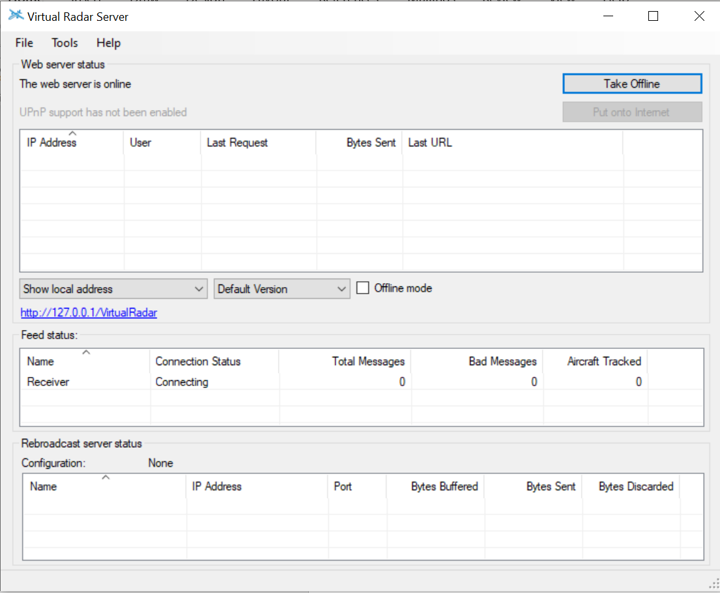

- Click on the blue hypertext in Virtual Radar (http://127.0......). If everything is working as expected you should be able to see aircraft and its path (assuming you’re in range)
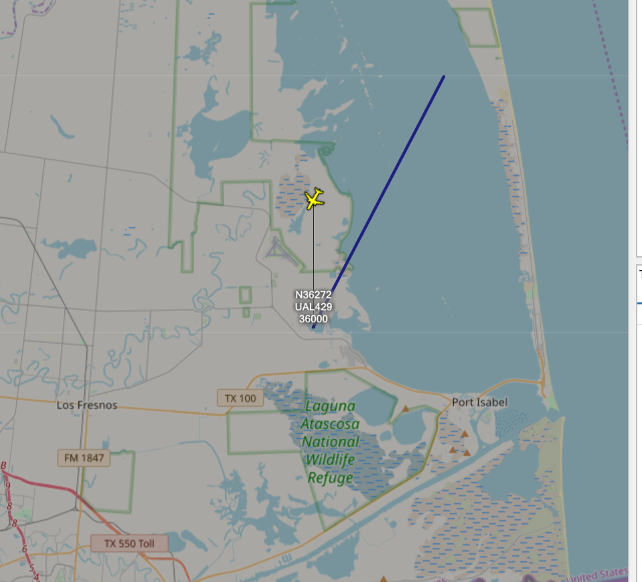

- On the top right, you can see information about the aircraft itself.
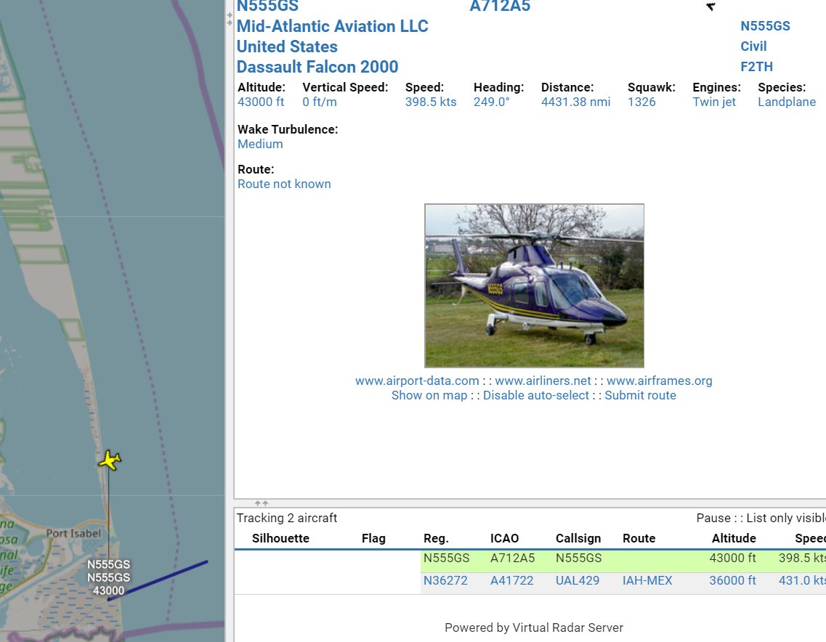

Notes:
- Error -12 in .bat file.

- Go to device manager and right click, click “uninstall device” the driver under Universal Serial Bus devices
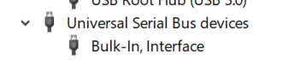

- Go to https://zadig.akeo.ie/ and download zadig

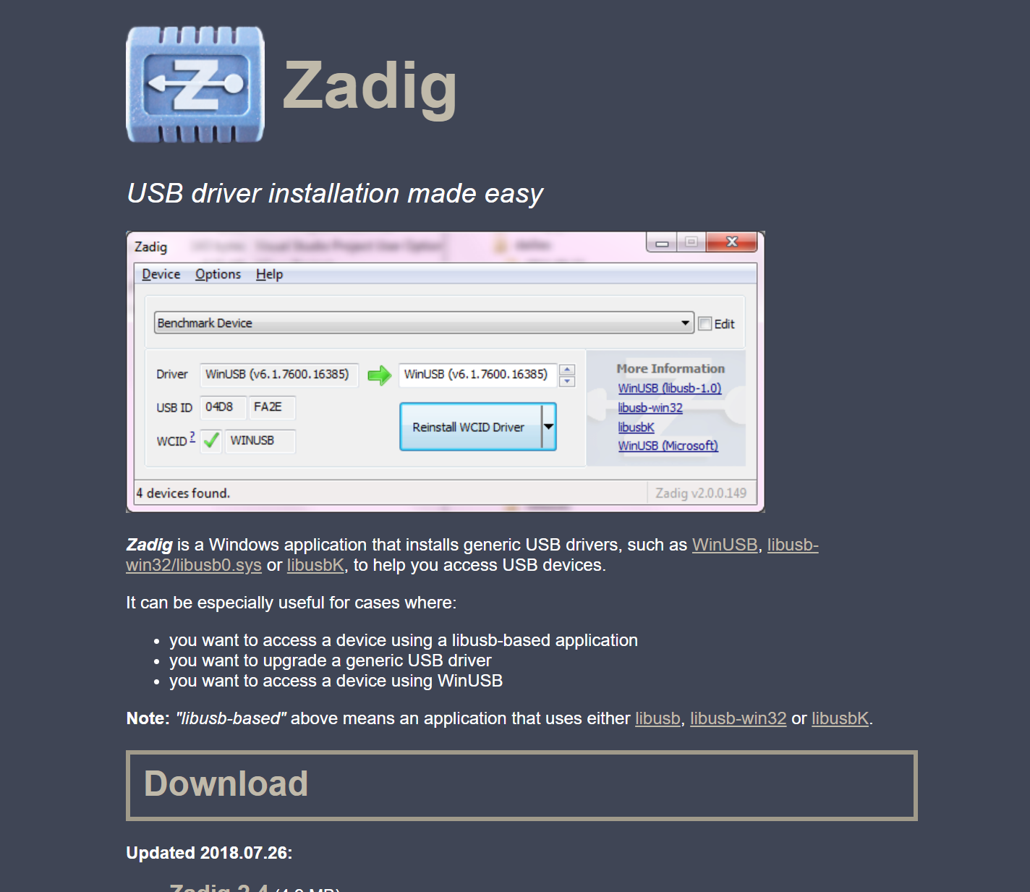

- Click options > “List All Devices” and UNCHECK “Ignore Hubs or Composite Parents”
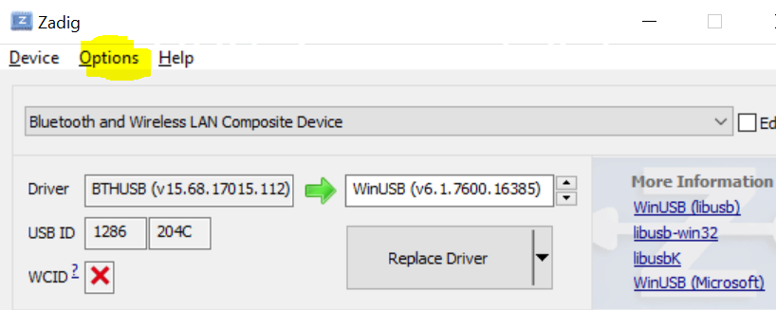

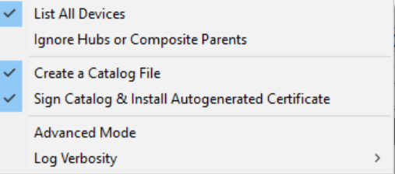

- On the drop down menu, select your RTL-SDR and click Replace Driver.
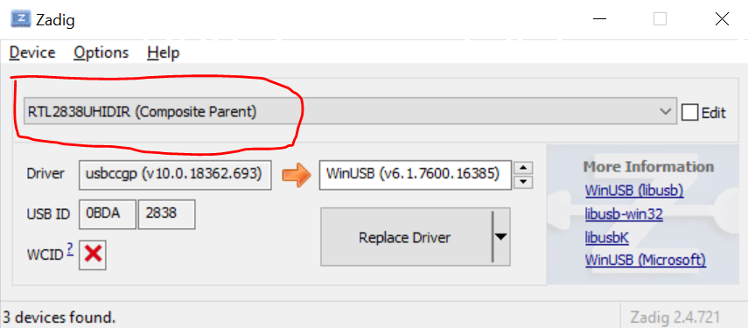

- Test your device by running the dump1090 bat file. You should see this below. This means your SDR is now working properly.

